Customer Registry
MERN Stack Full-Stack Web Application
Project Documentation
Repository: github.com/Saitejapalanki/Customer-Registry

1. Introduction
This document describes the design, architecture, setup, and usage of the Customer Registry application, a full-stack web application built using the MERN stack (MongoDB, Express.js, React, and Node.js). It is intended to serve as a reference for developers, testers, and reviewers working on or evaluating the project.

Project Title
Customer Registry

Team Members
Name | Role
Sai Teja Palanki | Team Lead
Talada Venkatesh | Member
Bommidi Navya Sree | Member
Mannem Priyanka | Member
Sudhakar Kaladindi | Member

2. Project Overview

Purpose
Customer Registry is a web-based application that allows an organization to record, manage, and track customer information in a centralized, searchable system. It replaces manual or spreadsheet-based record keeping with a structured, database-backed registry accessible through a browser.

Goals
- Provide a simple, reliable interface for registering new customers.
- Allow staff to view, search, update, and remove customer records.
- Persist all customer data securely in a MongoDB database.
- Expose a clean REST API that separates frontend and backend concerns.

Key Features
- Customer registration form with client-side and server-side validation.
- Dashboard/list view of all registered customers.
- Search and filter customers by name, phone, or other attributes.
- Edit and delete existing customer records.
- Responsive UI built with React components.
- RESTful API backend built with Node.js and Express.js.

3. Architecture

Frontend (React)
The frontend is a single-page application built with React. It is organized into reusable functional components (e.g., forms, tables, navigation) and uses component state and props to manage UI data. API calls to the backend are made using fetch or Axios, and React Router (if used) handles client-side navigation between views such as the registration form, customer list, and edit pages.

Backend (Node.js & Express.js)
The backend is a Node.js application using the Express.js framework to expose a RESTful API. It follows a typical MVC-style structure: route handlers receive HTTP requests, controllers contain the business logic, and Mongoose models define the shape of the data stored in MongoDB. Middleware handles concerns such as request parsing, CORS, and error handling.

Database (MongoDB)
MongoDB is used as the primary data store, with Mongoose as the Object Data Modeling (ODM) layer. Customer records are stored as documents in a customers collection. A typical customer document includes fields such as:
Field | Type | Description
_id | ObjectId | Unique identifier auto-generated by MongoDB
name | String | Full name of the customer
email | String | Customer email address
phone | String | Customer contact number
address | String | Customer address
createdAt | Date | Record creation timestamp
updatedAt | Date | Record last-updated timestamp

4. Setup Instructions

Prerequisites
- Node.js (v16 or later recommended) and npm
- MongoDB (local installation or a MongoDB Atlas cluster)
- Git
- A code editor such as VS Code

Installation
1. Clone the repository:
git clone https://github.com/Saitejapalanki/Customer-Registry.gitcd Customer-Registry
2. Install backend dependencies:
cd servernpm install
3. Install frontend dependencies:
cd ../clientnpm install
4. Configure environment variables. Create a .env file in the server directory with values such as:
PORT=5000MONGODB_URI=<your MongoDB connection string>JWT_SECRET=<your secret key>

5. Folder Structure

Client (React frontend)
client/ public/ src/ components/ # Reusable UI components (forms, tables, navbar) pages/ # Page-level views (Home, Add Customer, Edit Customer) services/ # API call helpers (Axios/fetch wrappers) App.js index.js package.json

Server (Node.js backend)
server/ models/ # Mongoose schemas (e.g., Customer.js) routes/ # Express route definitions controllers/ # Request handlers / business logic middleware/ # Auth, validation, error handling config/ # Database connection, environment config server.js # Application entry point package.json

6. Running the Application
Frontend — from the client directory:
npm start
This starts the React development server, typically available at http://localhost:3000.
Backend — from the server directory:
npm start
This starts the Express API server, typically available at http://localhost:5000. Ensure MongoDB is running (locally or via Atlas) before starting the backend.

7. API Documentation
The table below outlines the typical REST endpoints for a customer registry API. Update method names, paths, and payloads to match the actual implementation in the routes/ and controllers/ directories.
Method | Endpoint | Description | Request Body
GET | /api/customers | Retrieve all customers | —
GET | /api/customers/:id | Retrieve a single customer by ID | —
POST | /api/customers | Create a new customer | { name, email, phone, address }
PUT | /api/customers/:id | Update an existing customer | { name, email, phone, address }
DELETE | /api/customers/:id | Delete a customer by ID | —
Example response for GET /api/customers/:id:
{ "_id": "64f1a2b3c4d5e6f7a8b9c0d1", "name": "Jane Doe", "email": "jane.doe@example.com", "phone": "555-0100", "address": "123 Main St", "createdAt": "2026-01-10T10:00:00.000Z"}

8. Authentication
Describe here how access to the application is controlled. If the project implements user login, a typical approach is:
- Users register/login with credentials verified against a Users collection in MongoDB.
- Passwords are hashed (e.g., with bcrypt) before being stored.
- On successful login, the server issues a JSON Web Token (JWT) that the client stores and sends in the Authorization header on subsequent requests.
- Protected routes are guarded by middleware that verifies the JWT before allowing access.

9. User Interface
Include screenshots or GIFs here showing the key screens of the application, for example:
- Customer list / dashboard view
- Add customer form
- Edit customer form
- Search/filter in action

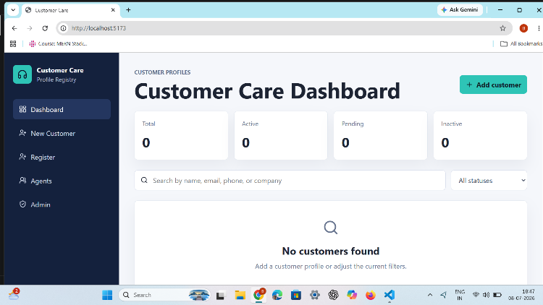
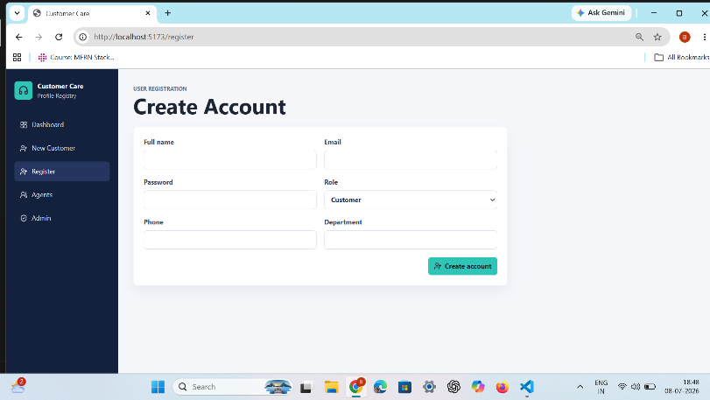
.

10. Testing
Describe the testing approach used for the project, for example:
- Unit tests for React components (e.g., using Jest and React Testing Library).
- API/integration tests for Express routes (e.g., using Jest or Mocha with Supertest).
- Manual testing performed against common user flows (add, edit, delete, search).

11. Demo
https://drive.google.com/drive/u/0/folders/1hyUjfRIDNWFr88XcIXPtYAe33BQ6nrS4

12. Known Issues
- Basic input validation needs improvement.
- Limited role-based access.
- Error messages can be more descriptive.
- Search performance slows with large data.

13. Future Enhancements
- Add user authentication and role-based access control (admin vs. staff).
- Add pagination and advanced filtering for large customer lists.
- Add data export (CSV/PDF) of customer records.
- Add automated test coverage for both frontend and backend.
- Deploy the application to a cloud platform (e.g., Render, Vercel, or AWS) with CI/CD.

